Task 2: Basic Wireshark Traffic Capture & Analysis
Name: Manohari S.J.
Dept: CSE core B section

- To capture my own network traffic using Wireshark and identify different protocols.

- I installed Wireshark and captured traffic using the eth0 interface. I browsed a few websites like wikipedia, google,and searched a few and captured the network packets for a short time. The final capture had 141 packets and 0 dropped packets.
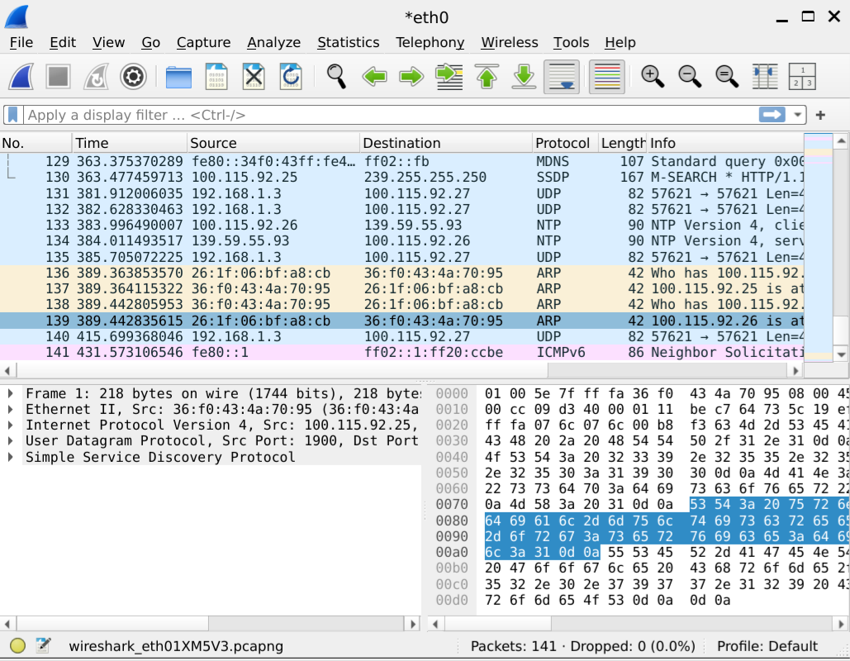

3. Protocols Identified
- ARP: Used to find the MAC address related to an IP address on the local network.
- mDNS: Used for local name and service discovery. It uses UDP port 5353.
- NTP: Used for network time synchronization.
- SSDP: Used for discovering devices and services on a local network. It uses UDP port 1900.
Screenshot – ARP packets
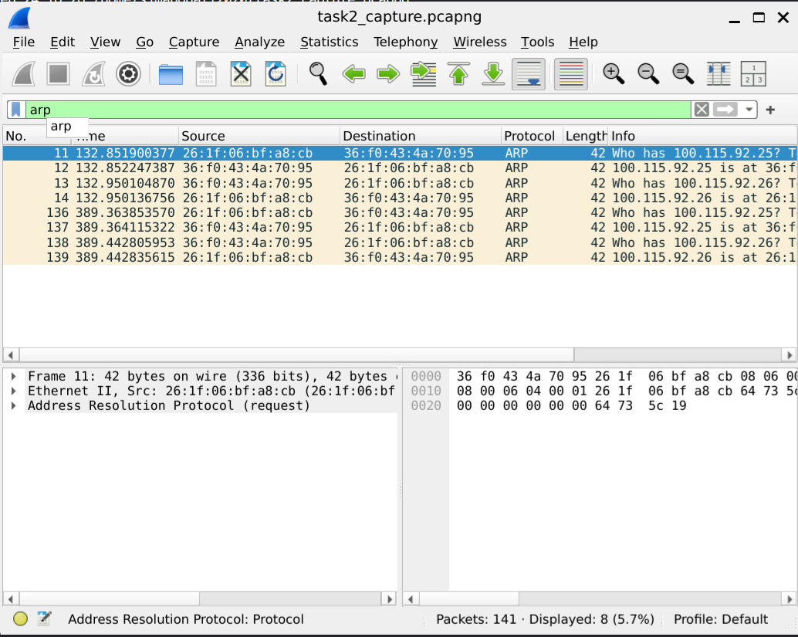
Screenshot – mDNS packets
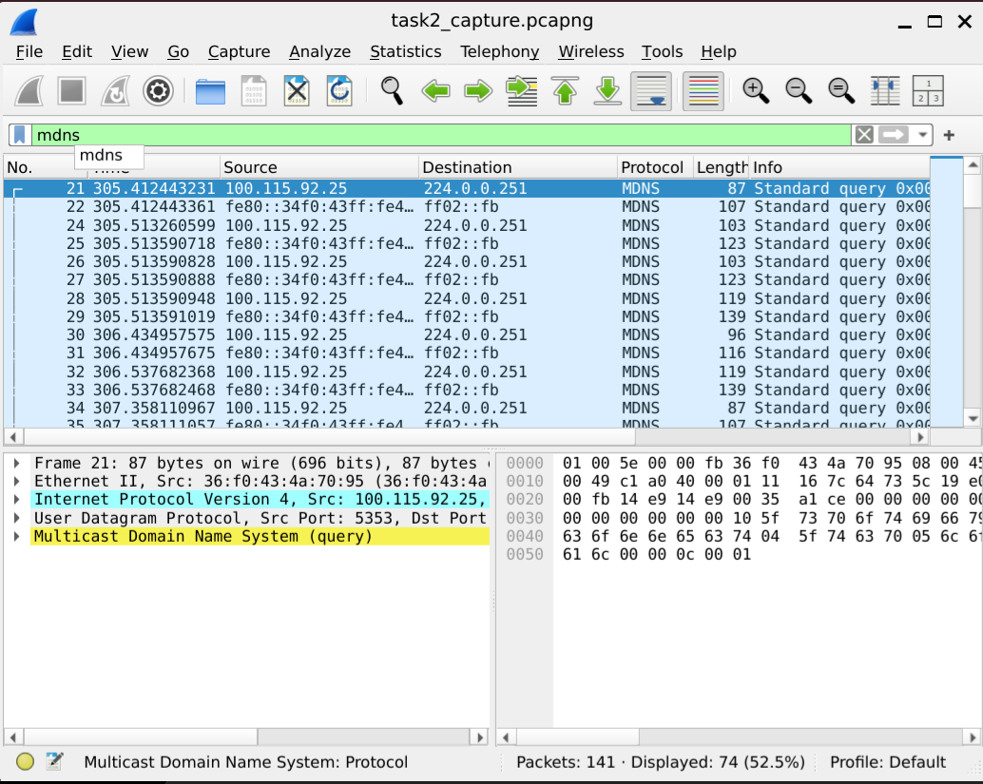
Screenshot – NTP packets
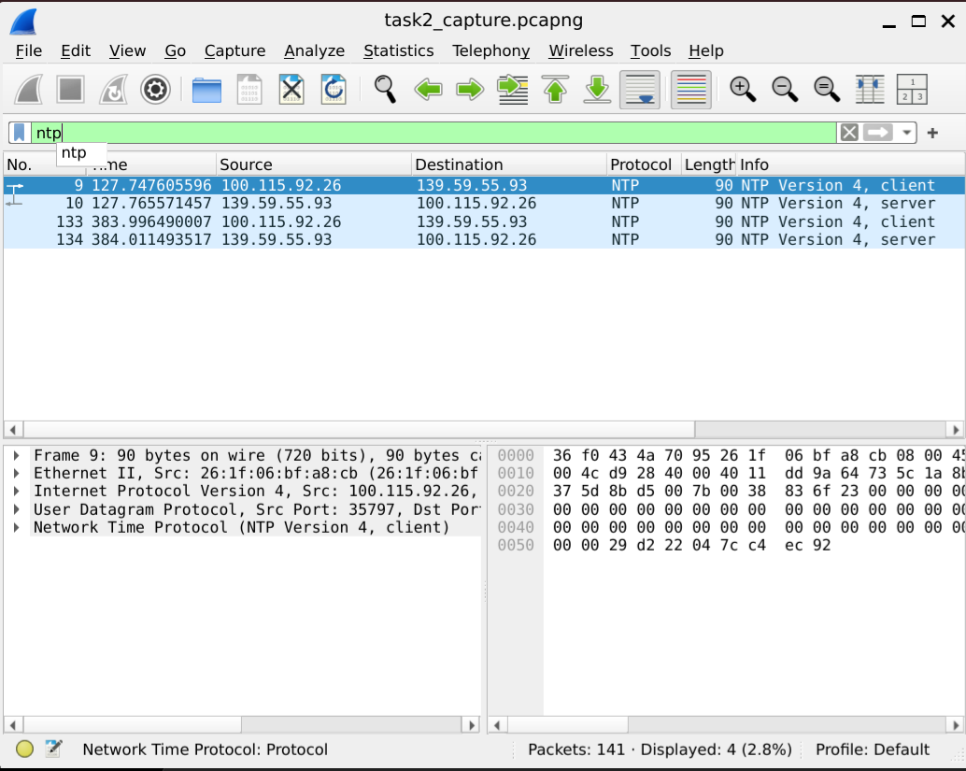
Screenshot – SSDP packets
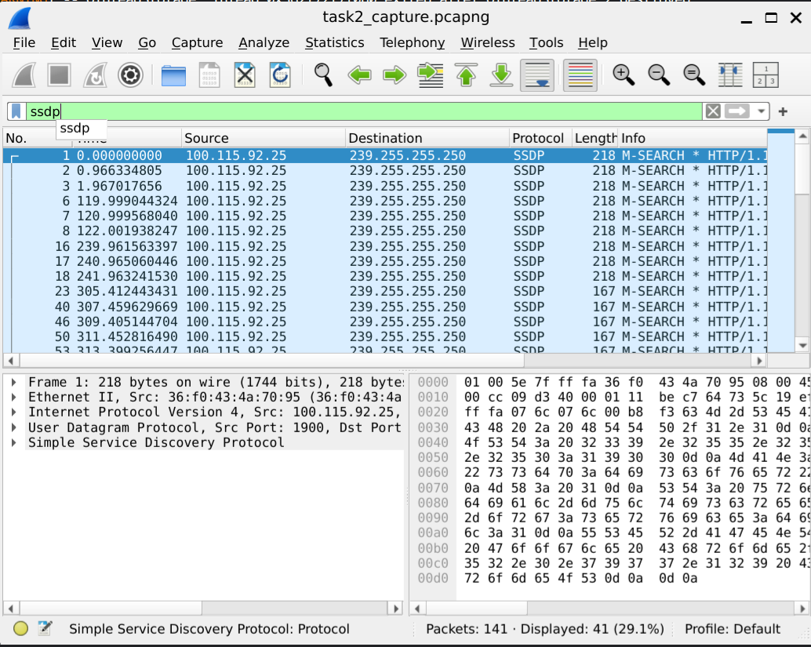

4. Packet Walkthrough – ARP
I selected an ARP exchange because it was easy to understand from the captured packets.
Packet 11: The device sends an ARP request asking, "Who has 100.115.92.25?" The source MAC address shown was 26:1f:06:bf:a8:cb.
Packet 12: The device with IP address 100.115.92.25 replies with its MAC address 36:f0:43:4a:70:95.
So, the first packet asks for the MAC address and the second packet gives the answer. This helps the devices communicate on the local network.
Screenshot – ARP packet walkthrough

5. Unencrypted Traffic
I noticed that protocols such as ARP, mDNS and SSDP were visible directly in the capture. Their packet information could be inspected without encryption.

6. What I Learned
I learned how normal network activity creates different types of packets. And also understood how ARP works and how mDNS, NTP and SSDP are used. I also learned how Wireshark filters can be used to find specific protocols.

